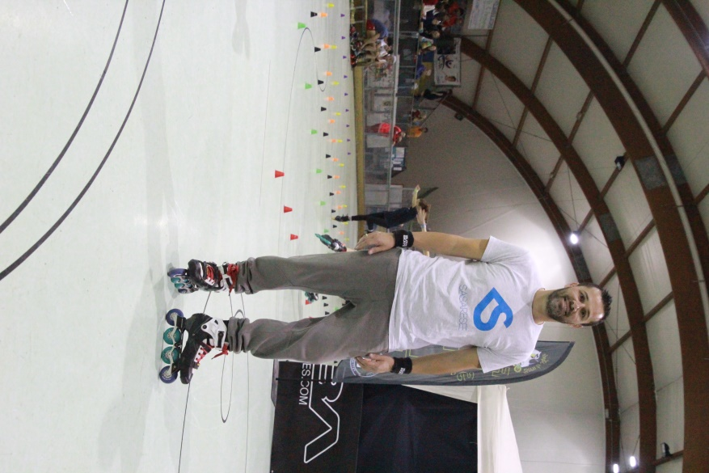

***So at July 2017 I went in my first competition at PSWC in Paris. I was so excited about that because I saw from very close and I skate with them all this famous and fantastic freestyle slalom skaters. After Paris I thought that it was my first and the last competition… but, the day before I left Paris, I said goodby to Chiara Lauldi. She told me «George: you have to come in Busto Battle competition..Busto is my home town». I told her that I appreciate his invitation and that I would try to go. After one month I did the pre-registration form for the Busto Battle VIII! I could not believe I did it because I have family, a child and a job so, travelling for me is difficult. Finaly, 10 days before the competition, I decided to come in Busto Battle and Chiara helped me so much. I want to thank Alessandro Romano and his family, Chiara Lauldi, the “Accademia Bustese Pattinaggio” and all members of the Busto Battle Team because they made my visit perfect and helped me to realize my dream to compete in European Championship of freestyle skating. Hope to see you all next year.”***

**In 8 editions, Busto Battle has seen athletes coming from all over the world. This year, for the first time, among the flags of the nations participating in the championship, there was and waving the flag of Greece. To bring this flag an athlete arrived alone from Athens. His passion for skating was visible looking his shine eyes to look the skating area. His Name is George Karpis. We spent a lot of time together. We asked him to tell us what led him to the Busto Battle VIII – European Champioship…. *“I started skating 4.5 years before. At October 2013, a skater from France, Igor Cheremetieff came in Athens. When i saw him to slalom, I realized that is what i want to do! He was and is my motivation. Anyway, after 2 days I bought 10 cones and i starded to practise alone. I was watching videos in Youtube and I was trying to copy the moves. I do not have instructor, I do not have anybody to teach me: just myself and my desire to do it! It is very difficult.***

**The First time of Greece at Busto Battle**

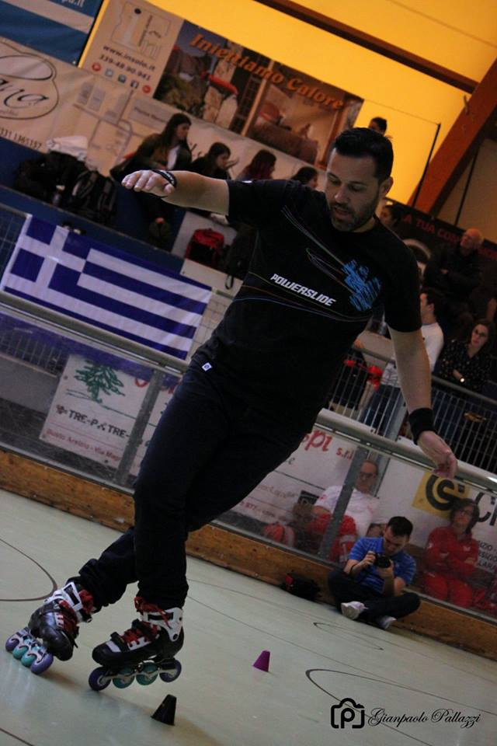

**For us it was a pleasure to welcome you, to see you during your classic performance and especially to know your overwhelming passion for skating. We hope to see you again at the next edition of Busto Battle.**